2019 亞東 熊佩韋 (Endometrial Cx)
一路慢慢聊天，一邊教學，輕鬆無壓力
- Endometrial cancer cervical stroma invasion, left iliac LN positive.
What is your management , planning dose，FIGO期別
Ans: FIGO stage IIIC1, 手術 + adjuvant CCRT
- 為何要加化療? 有無evidence?
Ans: 我回答目前沒有solid evidence,不過PORTEC-3 的2019 update subgroup有發現stage III做CCRT有較好的PFS及OS benefit, 熊主任也接受
- Whole pelvis RT你的建議是? 範圍要做多大?
Ans: [NCCN] WPRT filed (45-50Gy): lower common iliac, external iliac, internal iliac, parametria, upper vaginal, paravaginal tissue and presacral lymph nodes (in patients with cervical involvement)
[NCCN] [ target the gross disease (if present)
gross residual disease and the area boost to 60–70 Gy
gross nodal disease, consider boost to 60–65 Gy ]
- 需不需要brachytherapy? 劑量? 做法? RAL-IV的長度你預計做多少?
Ans: [question-based] The overall benefit of adding VBT to pelvic RT is under question, several retrospective studies had suggested small/negligible benefit.
(1) adjuvant pelvic RT is indicated for invading cervical stroma. Consider chemo for G3
(2) Combination of deep myometrial invasion and LVI+.
-IVRT followed WPRT dose：[NCCN] 4-6 Gy x 2-3 fxs to vagina mucosa
-IVRT治療長度：proximal 3-5 cm, if Gr 3, clear cell, serous, extensive LVI, treat entire vagina 7cm
- Endometrial CA >50% myometrial invasion, G2, LVSI(+), post-op management? dose?
Ans: [NCCN] IB, G2 (IVRT preferred) or consider EBRT for HIR (GOG249)
GOG249 High-intermediate risk: LVI, G2-3, outer 1/2 involvement;
≧70y/o +1 factor, ≧50y/o +2 factors, <50y/o +3 factors
- Brachy (IVRT) dose? prescription to? OAR dose?
Ans: IVRT only dose：[NCCN] 7 Gy x 3 fxs or 5.5 Gy x 4 fxs to 5 mm below mucosa;
6 Gy x 5 fxs to vagina mucosa.
- GOG99, PROTEC-1, 2, 3 內容?有哪些risk factor?
GOG99 | IB  IC  Occult II | OBS vs WP(50.4Gy) | -WPRT improved LRR↑ (12 vs 3%), mostly among HIR pts (26 vs 6%) vs. LIR pts (6 vs 2%).  -No OS benefit  -High-intermediate risk:  (LVI, G2-3, outer 1/3 involvement)  ≧70 y/o+1 factor, ≧50 y/o +2 factors, <50 y/o +3 factors  -4-yr severe AE was 13% with EBRT.  -Majority of pelvic recurrences in vaginal cuff.
PORTEC-1  2000 Lancet  2005 RED  2011 JCO | IB G2/3  IC G1/2  (no IC G3) | OBS vs WP(46Gy) | -WPRT improved LRR↑ (15-yr 5.8% vs.15.5%)  -No OS benefit  -greatest LRR benefit with RT:  >2 risks: age > 60, G3, outer 1/2 involvement  -15 yrs long-term urinary and bowel symptoms and decreased QOL with EBRT.  -Mostly vaginal recurrences
PORTEC-2  2010 Lancet | -Age > 60 &  (IB G3 or  IC G1/2)  -IIA  (no IC G3) | EBRT(46Gy) vs VB (21Gy) | -No difference in 5-yr LR relapse, isolated pelvic recurrence or DM.  -VB had better QOL  -isolated pelvic recurrence was low (1.5 vs. 0.5%).
PORTEC-3  2016 Lancet  2019 Lancet | *Endometrioid:  -IA G3, LVI(+) -IB G3;  -II-III  *Serous or clear cell: stage I-III | EBRT +/- chemotherapy | *Initial:  -5Y FFS: 68%-->75%  -for stage III, FFS↑  *2019 updated: CCRT improve 5 year OS↑ FFS↑ in Stage III and serous carcinoma  No difference in stage I-II  •Higher incidence of AEs and decreased QOL with CRT

2019 雙和 李明憲 (Cervix)
- 45 y/o female cervical cancer adenocarcinoma 3 cm, biopsy adenocarcinoma, CT MRI no positive LN
A: Stage? Management?
Ans: stage IB2, Radical hysterectomy + pelvic lymphadenectomy
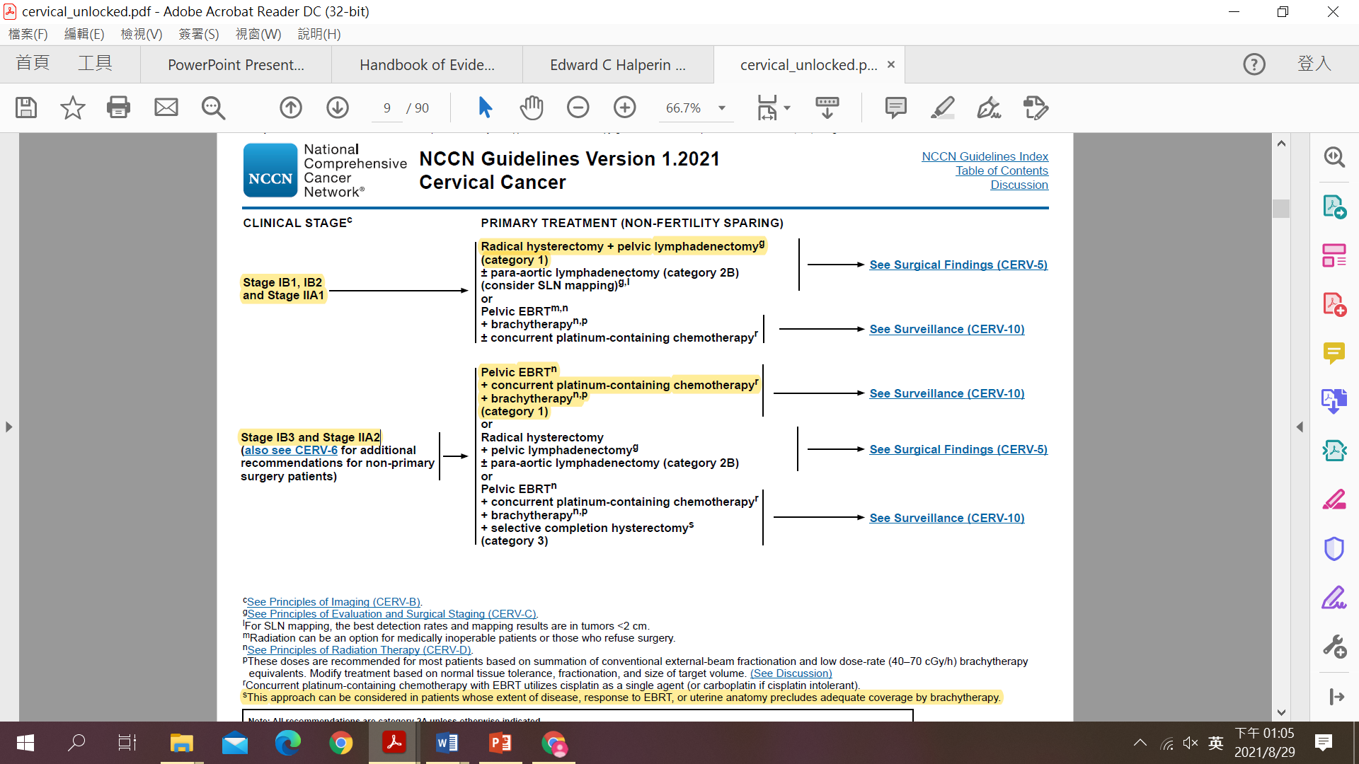

B: If the patient received simple hysterectomy at out hospital what is you planning?
Ans: 要先做基本survey, 評估手術方式及術後病理結果，Incidental finding after hysterectomy原則大致為EBRT ± Chemotherapy ± brachy, 詳細治療流程如下
(考官說主要看術後margin, image, 還有stage; 如果invasion parametrium或LN meta,那一定要加Chemotherapy)
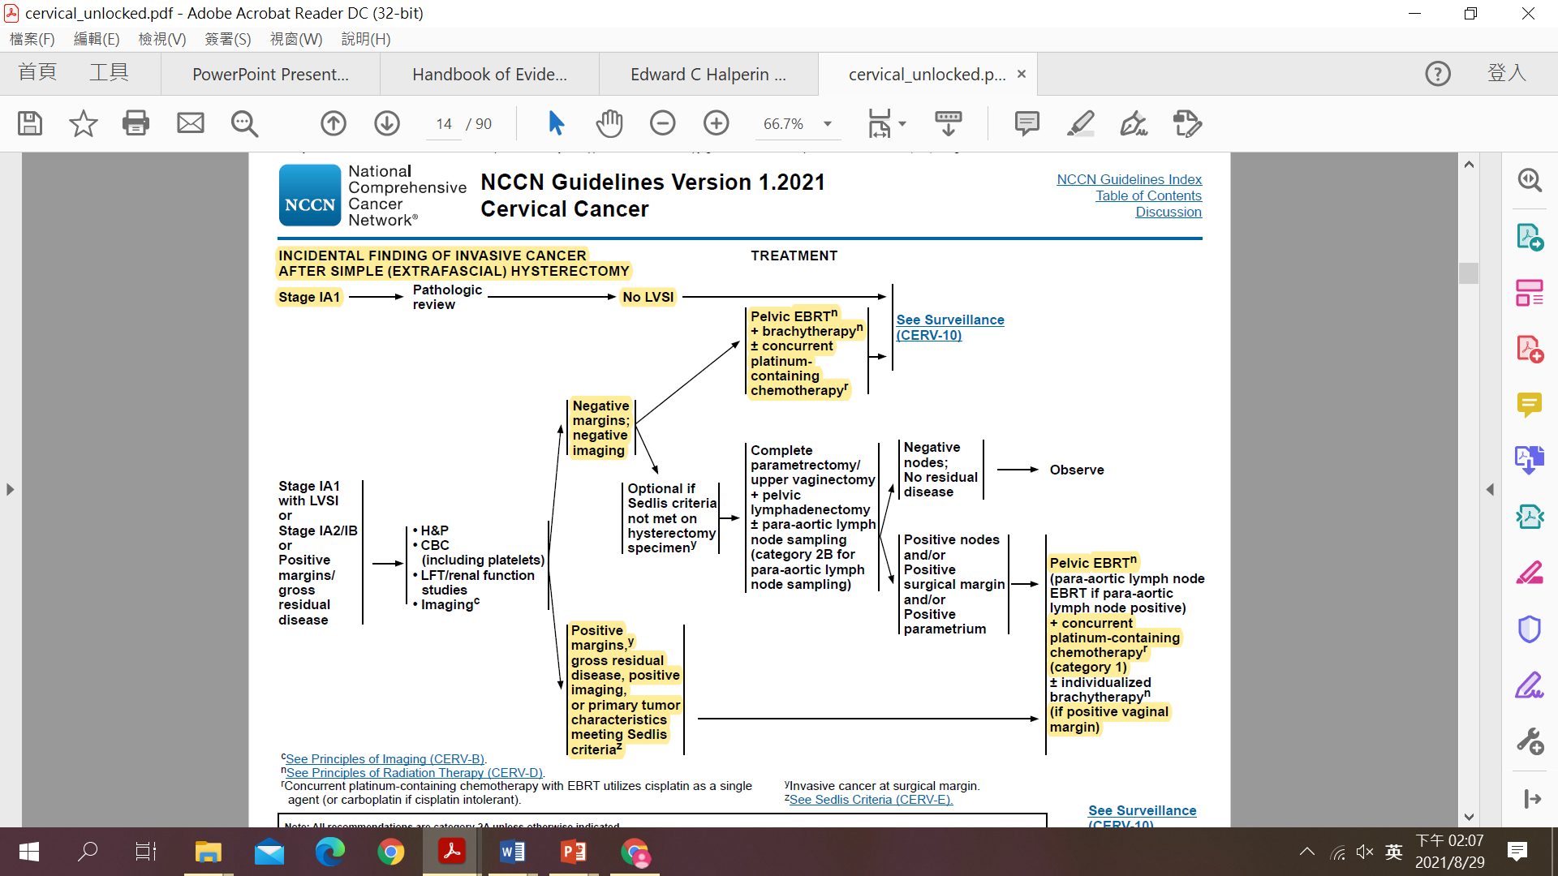

C: If patient was young lady want baby what is your management
Ans: [NCCN] Fertility sparing: 建議只有IB2以下，IA1 without LVI可以用cone biopsy就好，
IA1 with LVI,IA2, IB1, IB2都要radical trachelectomy + pelvic LN dissection
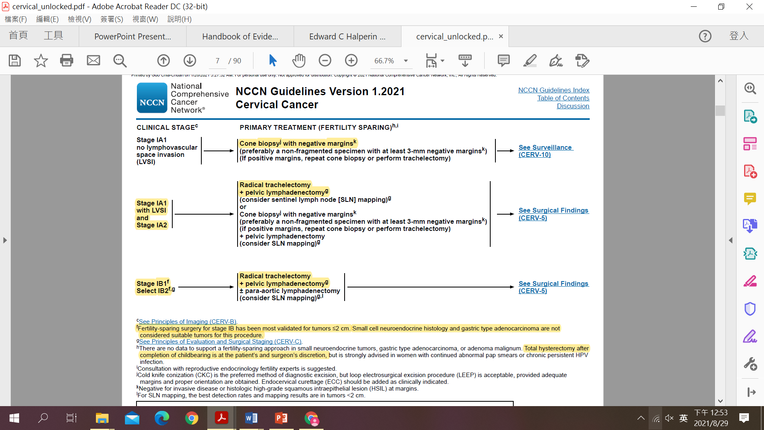
Radical trachelectomy示意圖
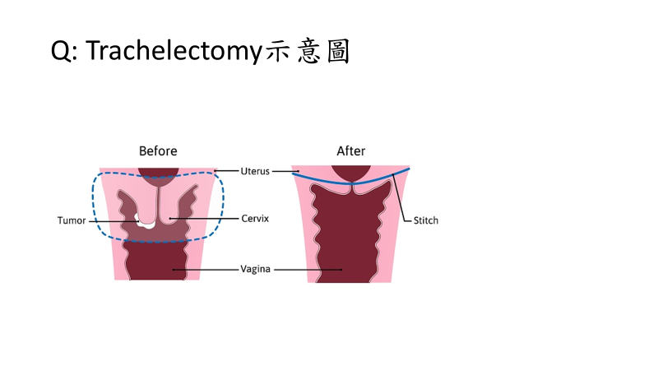

- Cervical ca, PV: side wall invasion, sono bladder invasion, IVP right hydronephrosis, what is your management?
Ans: stage IVA, Pelvic EBRT + concurrent platinum-containing chemotherapy + brachytherapy
(考官說重點在於回答整個臨床處置流程,不能只著重在要CCRT,包括考量是否已吃到ureter, 治療前應先舒緩hydronephrosis, 如先放double J, 還有考量腎功能, cisplatin有renal toxicity)

- If the PV invasion to the lower third vagina what is your management? brachytherapy器械選擇?
Ans: stage IIIA, Pelvic EBRT + concurrent platinum-containing chemotherapy + brachytherapy
[NCCN] For patients with lower 1/3 vaginal involvement, the bilateral groins should be covered as well.
(考官說重點在於invasion to lower third vagina要cover inguinal lymph node area, 另外會問brachytherapy器械選擇, 要選擇夠長可以包整個vagina的,例如Tandem and Cylinder或各家使用器械,理論上Tandem and ovoid不行)

- 病人開完刀資料如下
LVSI (+), Invade middle 1/3 myometrium, Tumor 2.5cm, Margin (-), LN(-)
請問之後給病人的建議?
Ans: Sadlis criteria 判斷是否RT-> Pelvic EBRT
